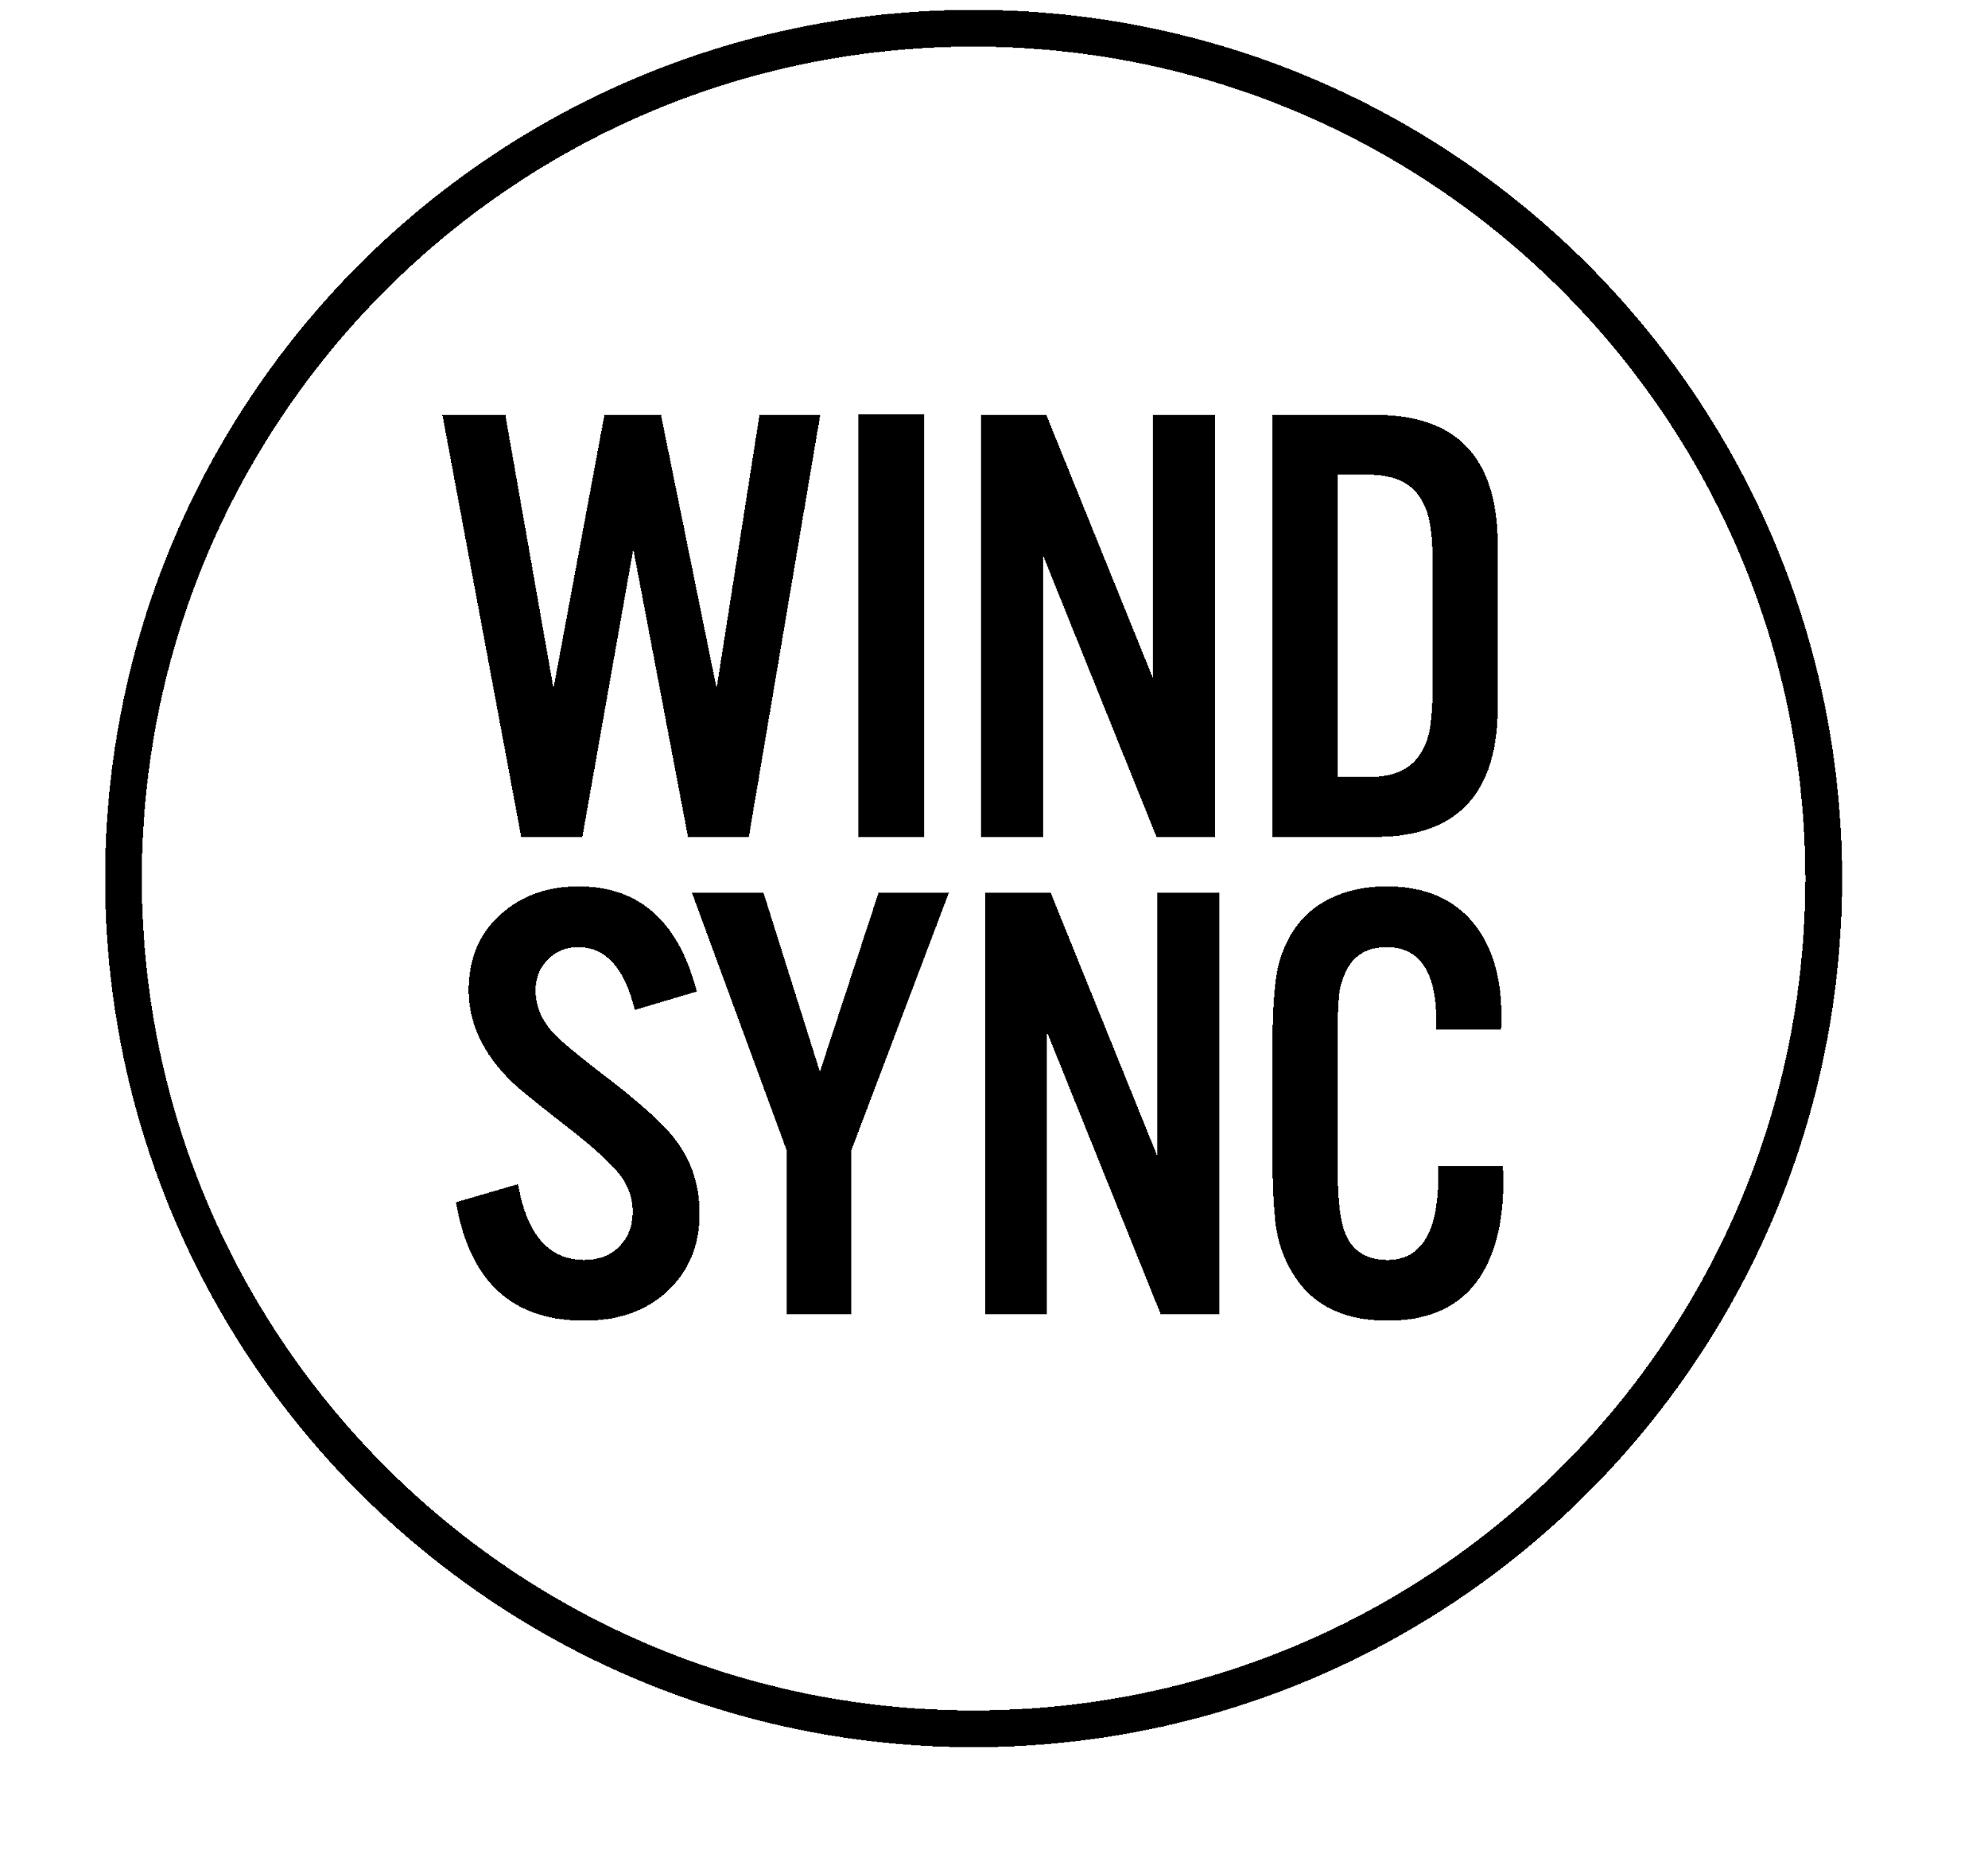

In its ninth season, the prizewinning Houston-based wind quintet builds highly thematic programs that feature landmark quintets, new works by American composers, and premiere arrangements of standard repertoire with the goal of increasing accessibility and cultural significance of wind chamber music. WindSync is recognized for dramatic, fully memorized concert presentations that often feature collaborators from the worlds of music, dance, and multimedia.

WindSync tours nationally and internationally, appearing at venues including the Schubert Club (MN), Met Museum, Shanghai Oriental Arts Center, and Weill Recital Hall at Carnegie Hall. In 2015, WindSync was invited by the Library of Congress to perform the world premiere of Paul Lansky's "The Long and the Short of it", commissioned by the Carolyn Royall Just Fund and the Chamber Music Society of Lincoln Center. WindSync’s most recent large-scale project is “The Cosmos,” a concerto for wind quintet and orchestra by Michael Gilbertson that received two performances in 2016. Other premieres include works by Paul English, Garrett Schumann, and Mark Buller.

WindSync takes a special interest in reaching children, families, and underserved audiences. Part of the burgeoning creative placemaking movement, the ensemble has recently focused on activating public spaces via music in Houston and in Opelousas, LA. They have been featured in educational concerts presented by the Seattle Symphony, Midland Symphony, and Orli Shaham's "Baby Got Bach", and their concerts for young people reach over 5,000 students per year.

Advocates of 21st century musicianship models and community-oriented programming, the members of WindSync have led master classes at New World Symphony, Texas Music Festival, and the University of Maryland Renegade Series, among others. WindSync has also served as ensemble-in-residence for the Chamber Music Festival of Lexington (KY), Grand Teton Music Festival, and the Da Camera of Houston Young Artists Program.

